**Week 1**

**Introduction to Data Visualization**

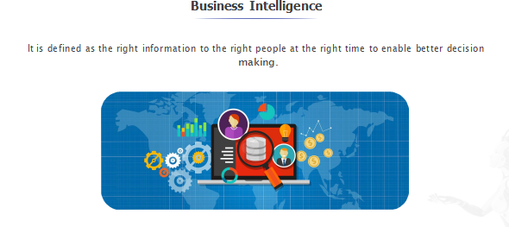

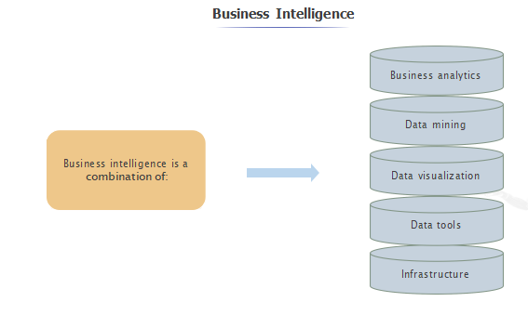

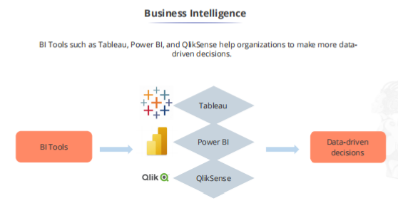

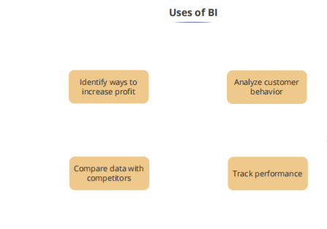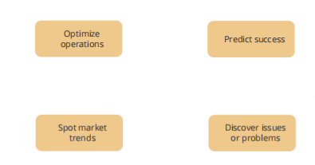

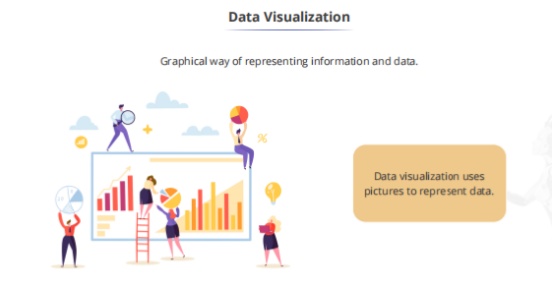

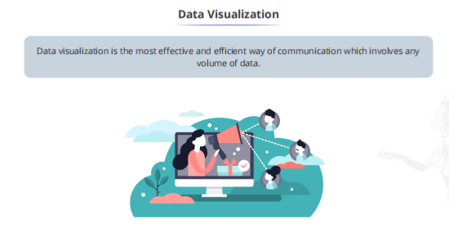

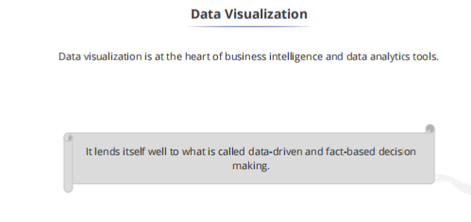

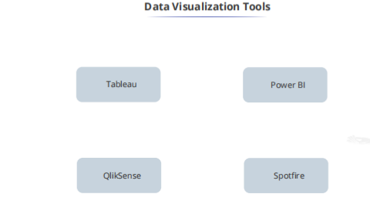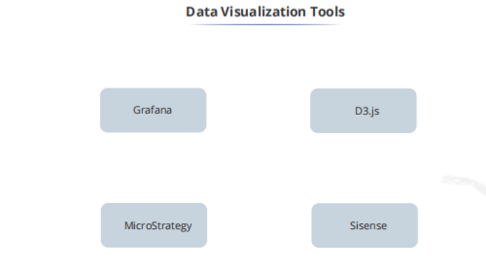



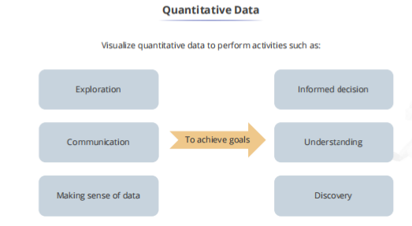

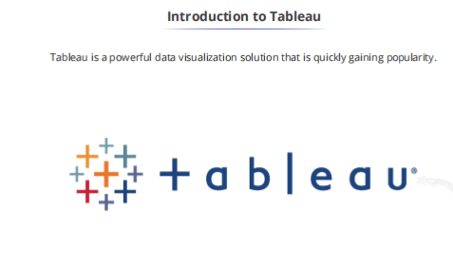

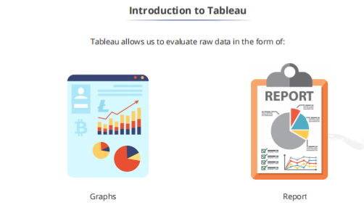

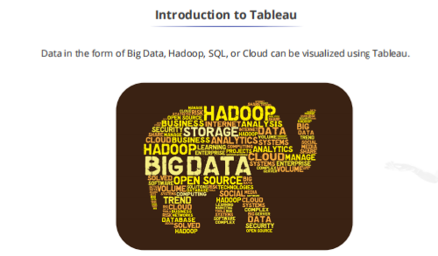

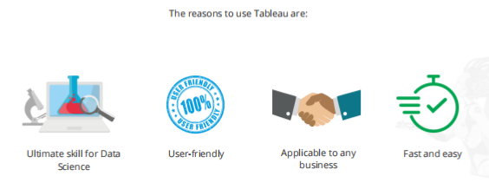

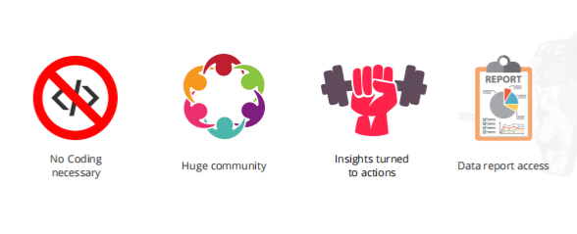

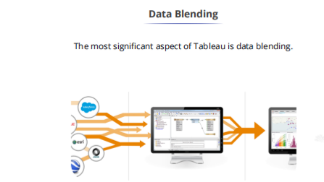

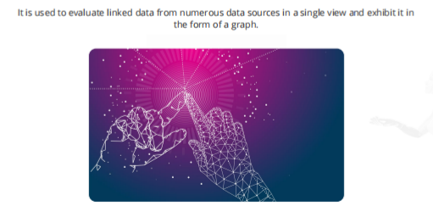

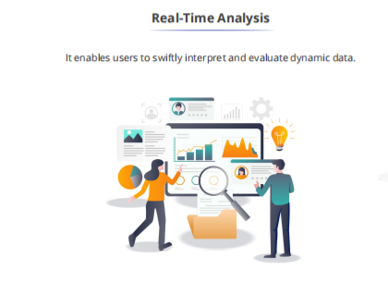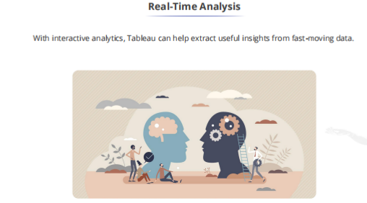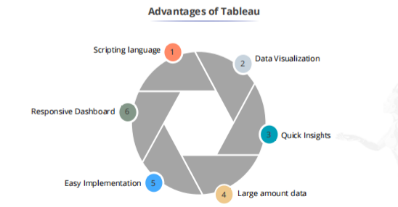

**Instructions to download Tableau Public**

Click on the below link to download the Tableau Public version

**https://www.tableau.com/products/public/download**

**To download student version of Tableau Desktop**

1. Click on below link

https://www.tableau.com/academic/students

2. Click on ‘Get Tableau for Free’

3. Enter your details

4. Enter your college name(DSCE) as School Name*

5. How will you be using your Tableau license?*

Select the option **Learning as part of course**

6. Click verify Student Status

7. Upload a picture of your College ID Card

8. The message below will be received

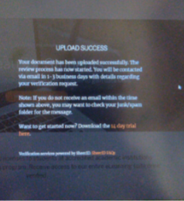

9. After verification, a mail from Tableau would be received with product key.

Step 2:

**Tableau Latest Version**

10. https://www.tableau.com/support/releases

11. Please install Tableau version

Tableau Latest Version

12. The file is approx. 480mb and would be downloaded.

13. Please click on the downloaded file and follow the instructions.

14. Run the exe file and enter the product key

15. Start Tableau and view the training videos

<https://www.tableau.com/learn/training/20202>

1. Find the graphical representation of category-wise sales data for the given data set of sample superstore.

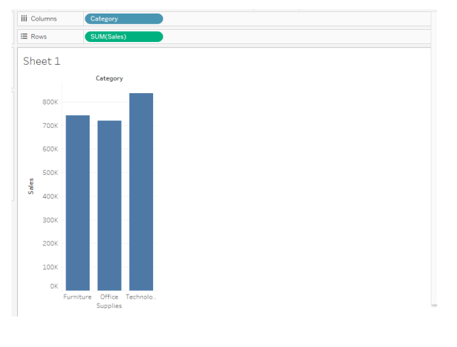

1. Find the sub-category wise Profit for the given dataset.

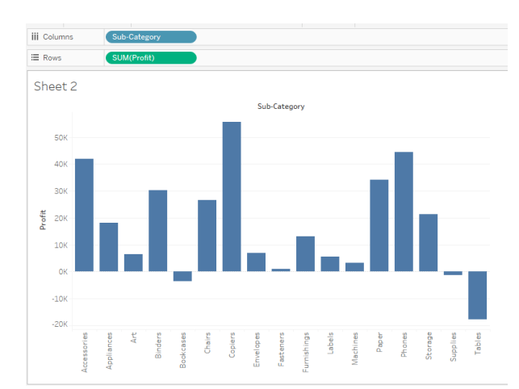

1. Explore the Profit of the category and respective sub Category, with highlighting each category in different color.

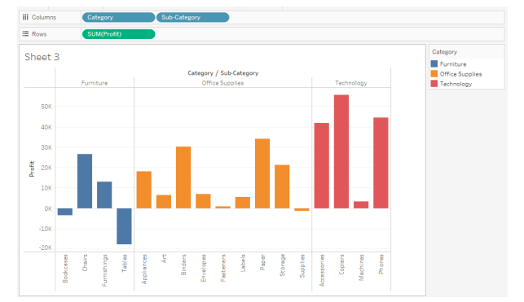

1. Explore the graphical representation of Profit and Sales of different category and sub-category.

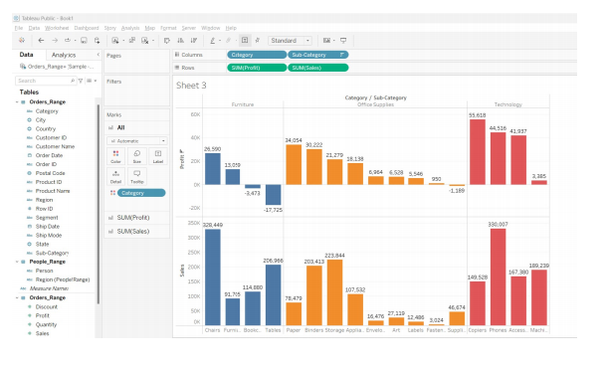

1. Find the sales according to the Order Date and Label it.

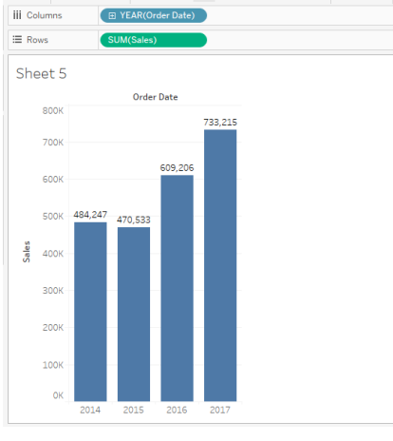

1. Find the year-wise, month-wise sales.

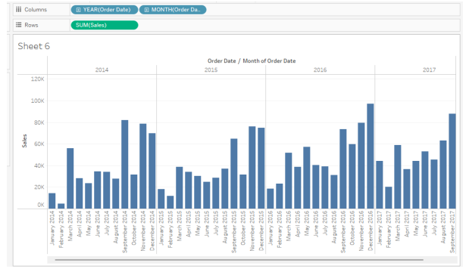

1. Analyse the sales of each product and find which product has highest sales.

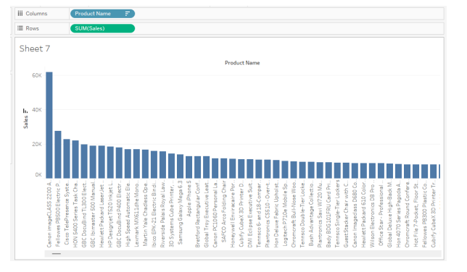

1. Find the region-wise, segment-wise sales with segments of different colors.

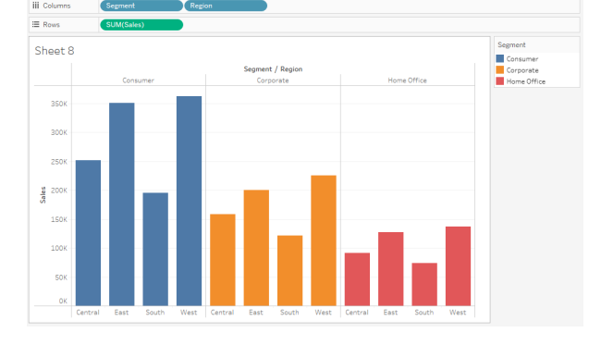

1. Find top 2 states with Maximum profit.

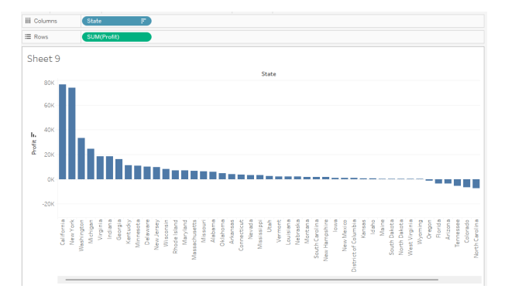

1. Analyse Region-wise , year-wise- Sales.

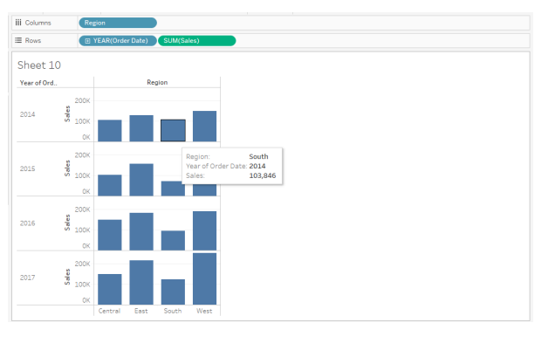

1. Which ship mode is preferred the most.

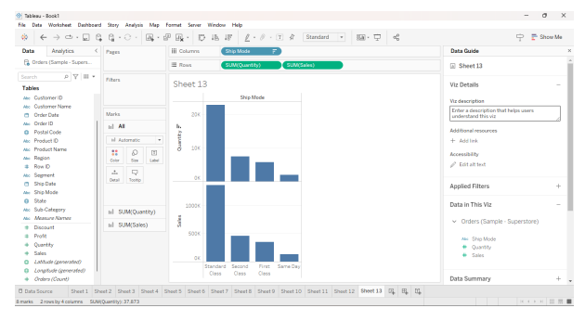

1. Get the graphical representation of profit for month-wise , year-wise , category.

